Earthworks Components
TD540 Display
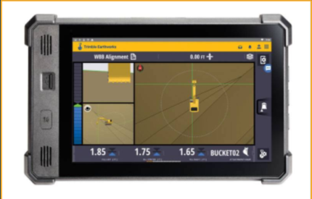
- 10.1” Sunlight Readable LCD Touchscreen
- Android Operating System
- Quick Release RAM mounting
- Secure platform for portability of grade control option keys
- Can operate in Landscape or Portrait mode
- Light bars integrated within operation screens
- Front facing USB for easy FW upgrade and synchronization of design and productivity data
- Power down delay configurable by user
- Split screen viewing configurable by user
- Can contain all Earthworks system licensing for both machine types
TD520 and TD510
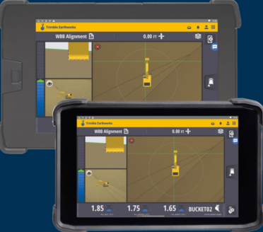
- TD520 is legacy 10.1” display (replaced by TD540)
- TD510 is a smaller format premium machine display for Trimble Earthworks.
- The 7-inch, daylight readable unit is smaller in physical dimensions when compared to the 10.1 inch Trimble TD520 or TD540 Display.
- Display utilizes a different connector than TD540. Adapters are required to swap display models between the TD540 and legacy displays
EC520 ECM
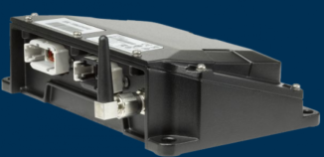
- Integrated Inertial Measurement Unit (IMU) body sensor with 6 degrees of freedom (3 Axis)
- 3 CAN ports for Machine CAN, HMI devices and grade control sensor connectivity
- 2 Ethernet ports for displays and radios
- Grade control system power management
- IP67 rated against dust, water, and shock
GS520 Grade Sensor
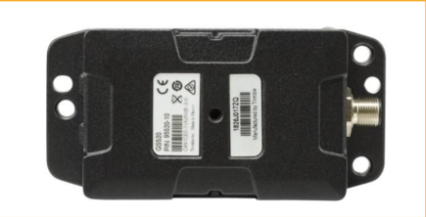
- Integrated Inertial Measurement Unit (IMU) grade sensor with 6 degrees of freedom(3 Axis)
- Suitable for harsh vibration environments (HEX bucket and dozer blades)
- Mount directly to linkage; no shock mounting required
- IP67 rated against dust, water, and shock
VM510 Valve Module
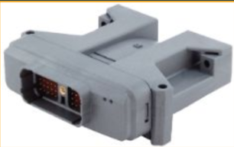
- Translates CAN messages from EC520 and sends to Machine Implement ECM
- Directly controls aftermarket hydraulic valve if one is installed.
- IP67 rated against dust, water, and shock
MS996 Receiver
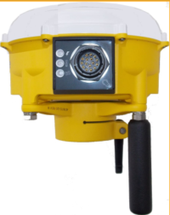
- Advanced RTK engine for faster initialization times when satellite lock is lost and enhanced performance near obstructions
- Same form factor as legacy MS995s with improved performance
- Support for GPS GLONASS, Galileo, BeiDou
- 3 LED indicators that provide instant operational feedback
- Tracks up to 44 Satellites
- Waterproof (up to 5PSI)
- Hardened against dust intrusion and shock
MS976 Receiver
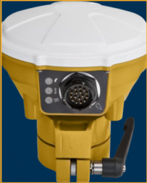
- Advanced RTK engine for faster initialization times when satellite lock is lost and enhanced performance near obstructions
- Same form factor as legacy MS975s with improved performance
- Support for GPS GLONASS, Galileo, BeiDou
- 3 LED indicators that provide instant operational feedback
- Tracks up to 44 Satellites
- Waterproof (up to 5PSI)
- Hardened against dust intrusion and shock
SNR930 Radio
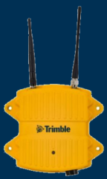
- 900 or 450 mhz Receive only radio
- LED provides information on radio status
- IP67 rated against dust, water, and shock
- Receives signal broadcast by base station and transmits to MS9x6 receivers over wiring harnesses
LR510 Laser Receiver

2D Machine Control
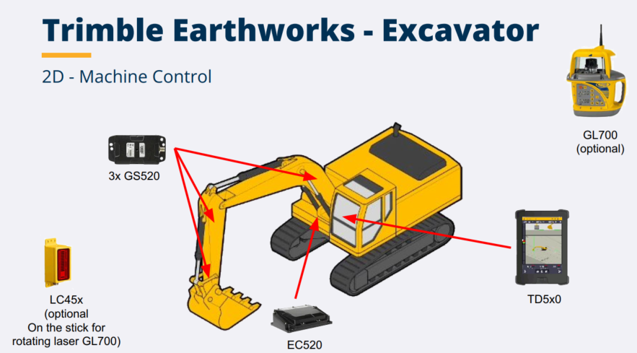
3D Machine Control – Single GNSS
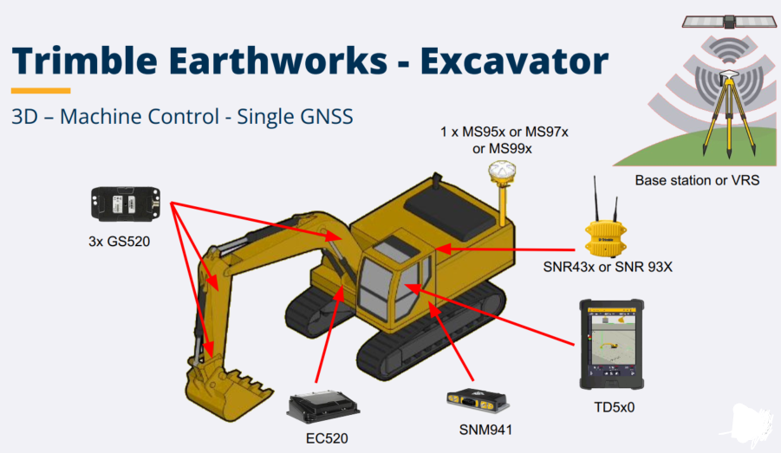
3D Machine Control – Dual GNSS
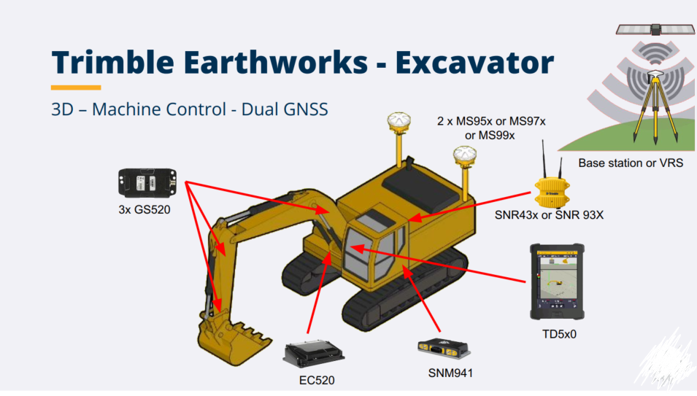
3D Machine Control – Single UTS
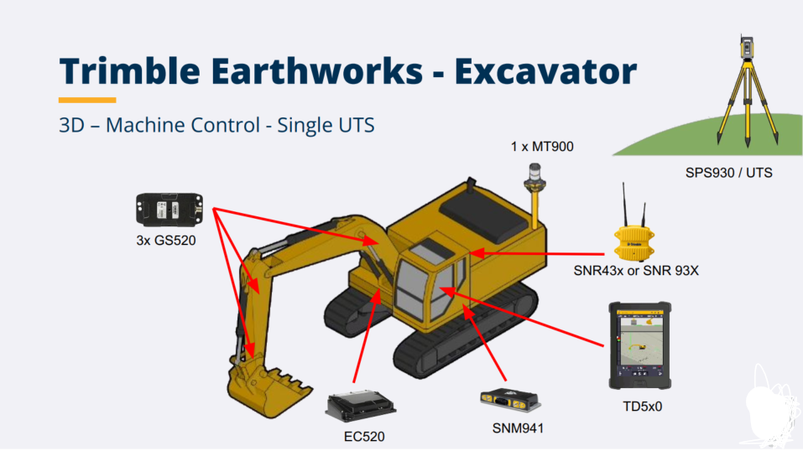
2D & 3D Machine Control – Additional Options
